

DevSoc Library App Project Proposal

Mobile Platform Applications



Hannah ASHNA JACOB

N0865554

Table of Contents

Executive Summary 2

Usability and Requirements 3

Guidelines 4

The Developers Society Brand Guidelines 4

Google’s Design Guidelines 4

Buttons 4

Top App Bar 5

Navigation Drawer 5

Lists 5

Text Content 5

The 3:1 Contrast Ratio 6

Android’s Core App Quality Checklist 6

Constraints 6

NFC Stickers and Cards 6

Firebase (Cloud Database) 7

Maintenance and Support 7

Extenuating Circumstances 7

Proposed Idea and Impact 8

Impact on the Society’s Members 8

Impact on the Society’s Committee 9

Application Features 10

Evaluation of Paper Prototype 11

User Testing – Session 1 11

User Testing – Session 2 11

Appendix 12

Persona A – Alice 12

Persona B – Carl 13

Persona C – Beth 14

Paper Prototype A (Before user testing) 15

Paper Prototype B (After user testing) – Minimum Viable Product (MVP) 16

References 17

# Executive Summary

Managing a personal library can be a tedious task, especially with a community that continues to rapidly expand as each academic year passes by. The Developers Society (DevSoc) at Nottingham Trent University (NTU) has seen exponential growth in its member base in recent years and with so many people and requests to manage, handling their library has started to become a bit of a challenge.

The current issue the society faces is that whenever someone wants to borrow or return a book, they need to directly contact a member of the committee to be able to have the society’s records manually updated. Back when DevSoc was much smaller this was a manageable task but with tons of new members, hectic university schedules, and other life commitments, updating records by hand is now a thing of the past.

While there are numerous other library apps available via the Play Store they do not, however, meet the needs of the society. Apps such as ‘My Library’ (Keith, 2022) and ‘Bookshelf’ (Juretic, 2022) do provide the ability to store a collection of books in a database, however, there isn’t any sort of loan system for the books so that multiple users can access and interact with the library. On the other hand, apps such as ‘BorrowBox’ (Bolinda Digital, 2022) and ‘Libby’ (OverDrive, 2022) let users borrow books, though, this is in relation to a wide online database of e-books. The loan system doesn’t apply to a user’s custom book database. Moreover, the society would much rather have an app that is in line with the rest of its branding (i.e., colour scheme and logo). Thus, there is a need for a more tailored app for the society to use based on their requirements.

The proposed solution would be to develop an app that digitises the existing process using Near Field Communication (NFC) tags, cloud databases and mobile devices. By assigning a tag to each book stored in the society’s library, users can easily scan a book using their mobile device to either borrow or return it. The app will update the linked cloud database in real-time to ensure that the records reflect ongoing changes. The app will also include a custom hidden view for the committee only to review the current books out on loan and to whom.

The app will significantly reduce the time spent on organising book pick-ups and drop-offs for both the society’s members and committee and thus free up more space for organising events and attending to more high-priority society tasks. Moreover, it will improve the overall user experience of the process as it provides members with a greater level of independence when it comes to interacting with the library; there is no longer a need for the committee to handle every single request for books.

# Usability and Requirements

Through a thorough analysis of the target user group, three different personas were created (Personas, Appendix). The users of this app are all NTU students and members of the Developers Society, thus most if not all would have exceptional tech literacy and therefore not need as much guidance within the app itself. However, it is in the best interest of the users and client, to provide an easy-to-use app to prevent an unnecessarily steep learning curve.

Thus, in adherence with a variety of different guidelines, careful consideration will be taken concerning the app’s accessibility from a usability perspective (i.e., for people with visual impairments). Since text size can be modified within the device’s settings, the accessible design of the app will focus more on colour scheme choices and layout factors during the design and implementation phase.

Another usability factor is the need for an app that speeds up the existing process. Due to the need for a ‘middle-man’ committee member to handle the manual updating of records, the process to borrow and return a book can be quite tiresome. This is especially true for members who simply want to quickly borrow or return a book but must wait on a committee member to be available to assist them (Persona A and B, Appendix). Thus, by incorporating a cloud database to handle data management users can rely on their app instead without the additional wait times.

Subsequently, the need for a quick summary of a book’s contents and availability (Persona A and B, Appendix) is another usability factor. Information about a book needs to be displayed clearly and cohesively so users can find the information they’re looking for with ease. This prevents the need for them to travel onto campus just to figure out whether a book is right for them or even available. This usability factor also relates to the information displayed via admin mode for the committee members (Persona C, Appendix).

**Project Requirements:**

* **Must-Have:**
  + NFC Sticker Scanning capabilities for books
  + NFC Card Scanning capabilities for hidden committee access
  + The ability for a member to update their loan status via NFC scanning
  + The ability to view one’s current borrowed books list
  + The ability to create an account to login into the app with
  + The ability to view all the books within the library along with their additional details
  + The ability to view books and the user that’s borrowed them when in admin mode
  + Real-time database updates based on in-app actions
* **Should-Have:**
  + Reminder notifications for book loan due dates
  + The ability to delete an account via settings
* **Could-Have:**
  + The ability to add new books and remove old ones from the database via the app when in admin mode instead of via Firebase
  + The ability to search for books on the ‘library’ screen based on the title

# Guidelines

## The Developers Society Brand Guidelines

As this app will be designed for DevSoc, its aesthetics must be in line with existing ‘brand’ design guidelines. This primarily includes the use of the society’s logo, preferred font and colour scheme. All of this can be found within the publicly available assets repository (DevSoc, 2022).

## Google’s Design Guidelines

Through a quick survey of the user group within DevSoc it was found that about 60% of its current active member base are android device users with another 15% stating that they use both android and iOS devices (see Fig. 1). Thus, this project will focus primarily on adhering to Google’s Design Guidelines (Google, 2022) for android development. Included below are key component guidelines that the project will use to ensure ease of use and better accessibility within the application.

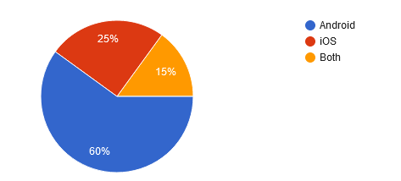

Figure : Survey results of the type of mobile device used by DevSoc members

### Buttons

This app will implement the use of buttons within most of its NFC interaction screens (Paper Prototype A and B, Appendix). This includes a mixture of icon buttons and text buttons. The text buttons will be used for yes or no responses from the user when asked if they’d like to borrow or return books. The icon buttons on the other hand will activate the NFC scanning feature.

As outlined in Google’s guidelines buttons should be identifiable, findable, and clear. They must indicate what they’re meant to do and what their current state is. Moreover, navigating to a button should be easy for a user when it’s incorporated alongside other elements. Buttons must also be responsive to changes in the layout. This is especially crucial for android app development since the types of android mobile devices vary greatly in screen size. Additionally, the button’s container should have a dynamic width that adjusts to the text content’s length and the container must have rounded corners.

### Top App Bar

For ease of use when navigating the app, a top app bar presents itself clearly to the user rather than a bottom app bar. Moreover, by displaying the name of the currently active screen via the app bar, it summarises and highlights what the current screen’s contents are to the user.

The app will incorporate a centre-aligned top app bar (Paper Prototype A and B, Appendix). Google’s guidelines outline the most ideal anatomy for the top app bar contents wherein the application’s hamburger menu and logo will be positioned on their corresponding sides.

The hamburger navigation menu must be placed in the leftmost corner while the interactive logo icon will be placed in the rightmost corner. Any text detailing what screen the user is currently on i.e., landing page, settings, etc. will be centre aligned.

### Navigation Drawer

As this application will have multiple different screens available for the user to navigate to, they need to be displayed in an accessible manner. With a navigation drawer, upon interacting with the top app bar’s hamburger menu, it will unlock the drawer which will display the different possible screen names to the user which they can then pick one to navigate to (Paper Prototype A and B, Appendix).

The guidelines highlight that the navigation drawer must open from left to right and that labels for screens are concise. The labels need to be descriptive enough for the user to understand what a screen’s contents might include.

### Lists

To display the contents of the different databases (the ‘library’ or the borrowed books lists) to the user on their screen, the app will employ the use of lists. As the lists' primary purpose is to communicate key information regarding the books (i.e., title, author name, availability, etc.) to the user, they must adhere to guidelines on appropriate list anatomy.

In line with Google’s guidelines, the app will use two-line list items (Paper Prototype A and B, Appendix) so that there is enough text space to cover all the necessary information. Moreover, each list item will include the title as the headline text followed by all the additional book information as supporting text. This will make it easier for the user to first navigate to a book they’re looking for before checking through the extra bits of information.

### Text Content

A key feature of the app is the text content (Paper Prototype A and B, Appendix) as it’s used on all the different screens. This includes its use in navigation elements, lists, and notifications. To ensure it serves its purpose in informing a user, the text must be readable. With regards to this project’s app, Google’s guidelines on ensuring readability highlight that the “ideal length” for shorter bodies of text is 20 to 40 characters and that the app should use a line height ratio of 1.2 for title texts and 1.5 for smaller text bodies.

## The 3:1 Contrast Ratio

This project aims to be accessible to a wide array of users and as a result, it will adhere to accredited accessibility guidelines concerning the design of the application’s features. The Web Content Accessibility Guidelines (WCAG, 2022) are recommended within Google’s Guidelines (Google, 2022) as a source to be considered even for android app development.

The purpose of the 3:1 Contrast Ratio guideline is to ensure that there is enough contrast between graphical elements so that individuals with visual impairments can identify an element correctly. This primarily applies to the app’s use of buttons wherein the button’s text and container should have enough contrast between them that a user can identify and read the text with ease. Google’s guidelines further highlight that this must be followed in cases where there are multiple buttons next to each other.

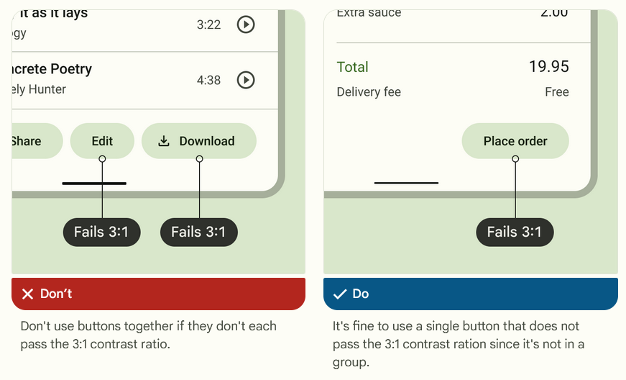

Figure : Diagrams depicting the importance of the 3:1 contrast ratio

## Android’s Core App Quality Checklist

In line with the project’s intention to build an accessible and easy-to-use app for its users, the app will also look to cover some of the core app quality items noted in Android’s app development checklist (Google Developers, 2022). This includes features like back-button navigation, notifications designed with the correct notification priority, and the app only requests the “absolute minimum” number of permissions needed for it to function. This is to ensure that the app is designed from the start to be fit for deployment to the Play Store.

# Constraints

## NFC Stickers and Cards

One key limitation of using NFC stickers is that they could potentially get damaged over time and need to be replaced or routinely checked as part of the maintenance process. This might potentially be a time-consuming process, however, when compared to the overall time it takes to manage the library using the existing process, the occasional maintenance and updating of NFC stickers are by far a much more efficient route.

Another drawback of using NFC stickers and cards is the investment element. The society needs to purchase quite a few cards for all their committee members and plenty more stickers for the books in the collection. Fortunately, the price of NFCs has dropped in recent years due to technological advancements allowing them to be made at a lower price. Thus, even with the need for an investment to be made, it isn’t a costly one.

## Firebase (Cloud Database)

Firebase will be used to store all the users’ account data and the library book collection data via a cloud database. A constraint of using a cloud database arises when a user loses access to the internet or has an unstable connection. This would result in them being unable to perform any actions within the app that’ll update the database. Moreover, it could also lock them out of their accounts if they don’t have internet access.

Subsequently, the app will employ the use of Firebase’s free features as it should account for the current user base requirements. A potential issue, however, is if the user requirements exceed the limit of the free features. This would result in the maintenance of the app requiring additional payments (Google Developers, 2022) on the side of the society’s committee.

## Maintenance and Support

As time passes, some books might need to be replaced or new books might need to be added. Thus, the database needs to be well maintained whenever real-world changes to the book collection occur.

In the case that the scope of the project allows for it once the primary requirements have been implemented, an additional feature that enables the committee to easily add and remove books will be added to allow an easier maintenance approach than having to update the database via Firebase’s website itself.

Learning to use a new process tends to have a learning curve and regardless of how steep it might be the necessary support needed for its adoption should be made available. Thus, a brief training session shall be provided to the committee so that they can master the features of the app to then share it with the rest of the society’s member base.

## Extenuating Circumstances

Unfortunately, the app cannot account for certain decisions made by individuals that loan the books. One such example of this might be when an individual decides they’d like to not return the book and thus forcing the committee to have to resort to taking over from the app to handle the issue themselves.

However, the likelihood of such a scenario occurring is quite low based on the history of the society’s library records. Moreover, the app is still able to support the committee with this process by keeping track of loan return due dates so that committee can keep on top of anyone attempting to avoid returning a book.

# Proposed Idea and Impact

The Developers Society (DevSoc) has an ever-growing collection of literature stored in a cabinet within their office. The mini library is open to the general member base to borrow, read and return which has given way to a rather challenging problem to manage. As the community size has now grown well beyond 800 members it has become increasingly difficult to try and keep track of who has taken a book and not returned it.

As discussed in an earlier section, despite there being numerous other existing alternatives such as: ‘My Library’ (Keith, 2022), ‘Bookshelf’ (Juretic, 2022), ‘BorrowBox’ (Bolinda Digital, 2022) and ‘Libby’ (OverDrive, 2022), none of these apps addresses the needs of the society. The primary requirement of this app is that there is a loan system wherein users can easily borrow and return books without the need for a member of the committee to facilitate the process. The apps mentioned above do provide a similar level of functionality but are limited to being only for online e-book libraries or not having a ‘borrowing’ system at all.

The solution to this would be a mobile app that’s easily accessible that allows users to scan a book via an NFC sticker before registering themselves as the current borrower. This information would then get stored on a cloud database that’s available for the current society’s committee to access. The database can then be updated in real-time to reflect availability changes happening to the books at any given moment.

## Impact on the Society’s Members

For members of DevSoc, the application would solve a few different issues. As discussed via the personas (Persona A, Appendix), users would be able to open the app and easily check the status of a book before making the trip down to Clifton Campus to collect it.

Moreover, the borrowing and returning process (Persona B, Appendix) would be simplified as it removes the need for the ‘middle-man’ committee member who currently must be present whenever a book is returned or borrowed so they can manually update the society’s records. With the NFC scanning feature, members simply need to open the app, activate the scanner, and scan a book. They’ll then just need to confirm if they’d like to borrow or return a book and the database will be updated accordingly in real-time.

Furthermore, with the use of a database members can view additional details about a book (i.e., author’s name or a summary) without having to look at the physical book. Finally, as the database stores data relating to the borrowing window/time limit, the application will be able to automatically notify a user of when they’re due to return the book without the committee having to chase the individual up themselves.

## Impact on the Society’s Committee

From a committee perspective (Persona C, Appendix) this system creates a more formal borrow and return process. The database would allow them to keep track of any book within their library without having to consult a series of different emails or paper records. With a simple scan of the NFC committee access card, the app would unlock the hidden database view that’ll display all the books and the user that has borrowed them. This significantly improves the amount of time that it takes for them to complete a simple check on a book’s status.

Furthermore, the NFC committee access card adds a layer of novelty and excitement to the app that allows the committee members to share a special hidden app feature amongst themselves that is functionally beneficial to them. In future work, this card could potentially unlock other features such as the ability to revoke a user’s access to book loans or the ability to modify loan durations for a particular user.

# Application Features

|  |  |
| --- | --- |
| **Feature** | **Implementation and Justification** |
| NFC Stickers on Books (NFC Scanning) | Allows the user to easily scan a book to borrow or return it via the application. Implemented using NFC stickers and NFC scanning within the app. |
| NFC Committee Access Card (NFC Scanning) | Unlocks hidden admin features within the application i.e., the ability to view the exact user that has borrowed a specific book. Implemented using NFC cards and NFC scanning within the app. |
| NFC Scanner Button (NFC Scanning) | This is an icon button that will activate the NFC scanning logic to ensure that we don’t need to have the app constantly checking and scanning in the background. This will also result in a pop-up so the user is aware of what changes are being applied to their accounts |
| Hidden NFC Scanner Button (NFC Scanning) | This will be disguised as the logo icon button within the top app bar and is a way to unlock the hidden scanning feature of NFC committee access cards. Only with a success will the app unlock the additional database information. |
| Firebase Database | Stores data on the users and books via the cloud so that it is easily accessible. Implemented using Firebase Databases. |
| The ‘Backpack’ | Allows the user to view all their currently borrowed books along with the remaining time left before they need to return it |
| The ‘Library’ | Displays all the books stored within the database alongside additional information i.e., author name and current availability status |
| Settings | Allows the user to easily sign out of the app or choose to delete their account and data from the database |
| Login Page (User Authentication) | Allows the user to securely log into the application and store all their app activity concerning their account. Enables easy transition between devices as all user data is hosted via the cloud database. Implemented via Firebase Authentication. |
| Landing Page | Displays key data that a user might want to see immediately after a successful login i.e., their currently borrowed books and the activate NFC scanner button |
| Notifications | Based on user testing feedback, notifications seemed to be a desirable feature. Thus, when a user’s time limit to borrow a book is about to end, the app will automatically notify them to prevent the need for the committee to chase after individuals themselves (Paper Prototype B, Appendix). |

# Evaluation of Paper Prototype

## User Testing – Session 1

During this session, the user noted that they’d prefer if there was a clear distinction of when the NFC scanning feature has been enabled or not. Currently, the app is set to constantly scan for the relevant NFCs though this might become too resource intensive for the device. Likewise, without a clear indication of when the scanner is active, the user might feel hesitant to install the app for security concerns.

Thus, through a revision in the design as highlighted in the revised prototype wireframe (Paper Prototype B, Appendix), with a dedicated button to trigger the scanning feature it ensures that the scanner isn’t running constantly in the background when it isn’t needed. Additionally, by including it as a button that the user must click to activate, it ensures that the user is explicitly aware of when the scanner is running. Furthermore, this is in line with the app quality checklist guidelines on app security wherein if a user denies the app access to a particular permission (i.e., NFC scanning) then they can continue to use the other features of the app.

## User Testing – Session 2

In this testing session, the user highlighted the need for a notification system. They noted that while the app itself does inform them of how long they have left to borrow a book if the user doesn’t constantly check this app they might not know about the deadline. Thus, it would be helpful to be able to get a pop-up notification that acts as a reminder outside of the app in addition to what’s available within the app. As seen in the new wireframe design (Paper Prototype B, Appendix), the app will now also include notification reminders for users that are due to return their books soon. The notifications will be designed in conjunction with the core app quality checklist (Google Developers, 2022) guidelines on notifications wherein they won’t be used for cross-promotion and that appropriate notification priority will be used.

Furthermore, the user also noted that when in the admin/committee view of the app, the ‘library’ and the ‘database’ screens both serve the same purpose and thus result in unnecessary duplication of data. The solution to this would be to remove the additional ‘database’ screen and just display more information via the ‘library’ screen.

# Appendix

## Persona A – Alice

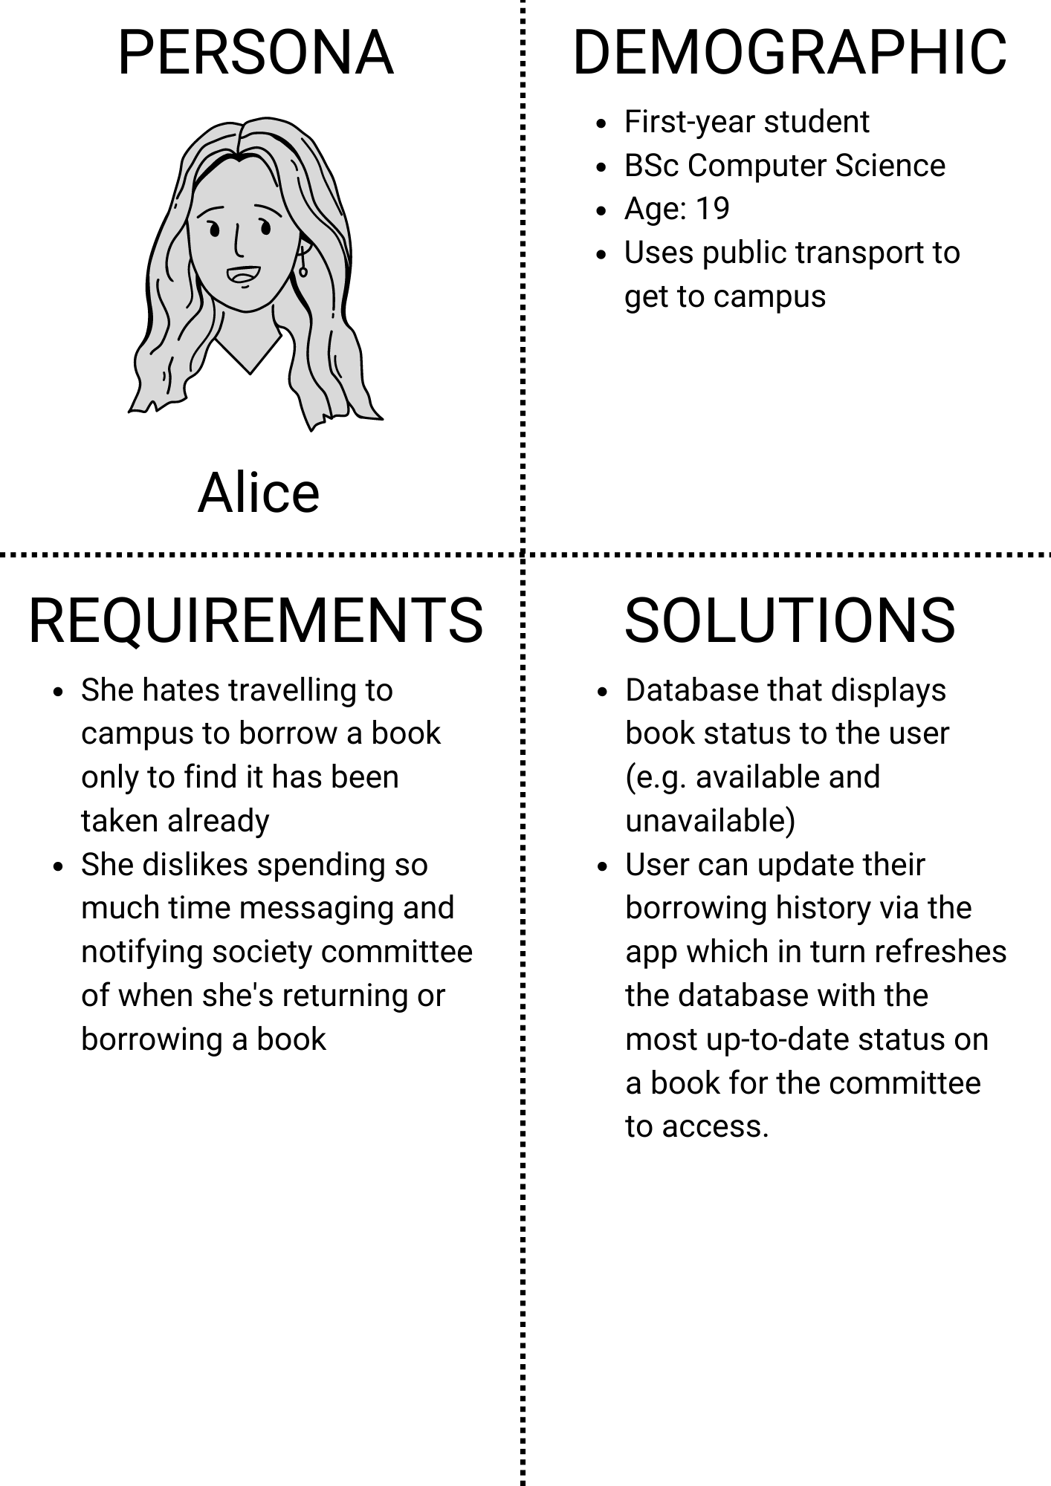

## Persona B – Carl

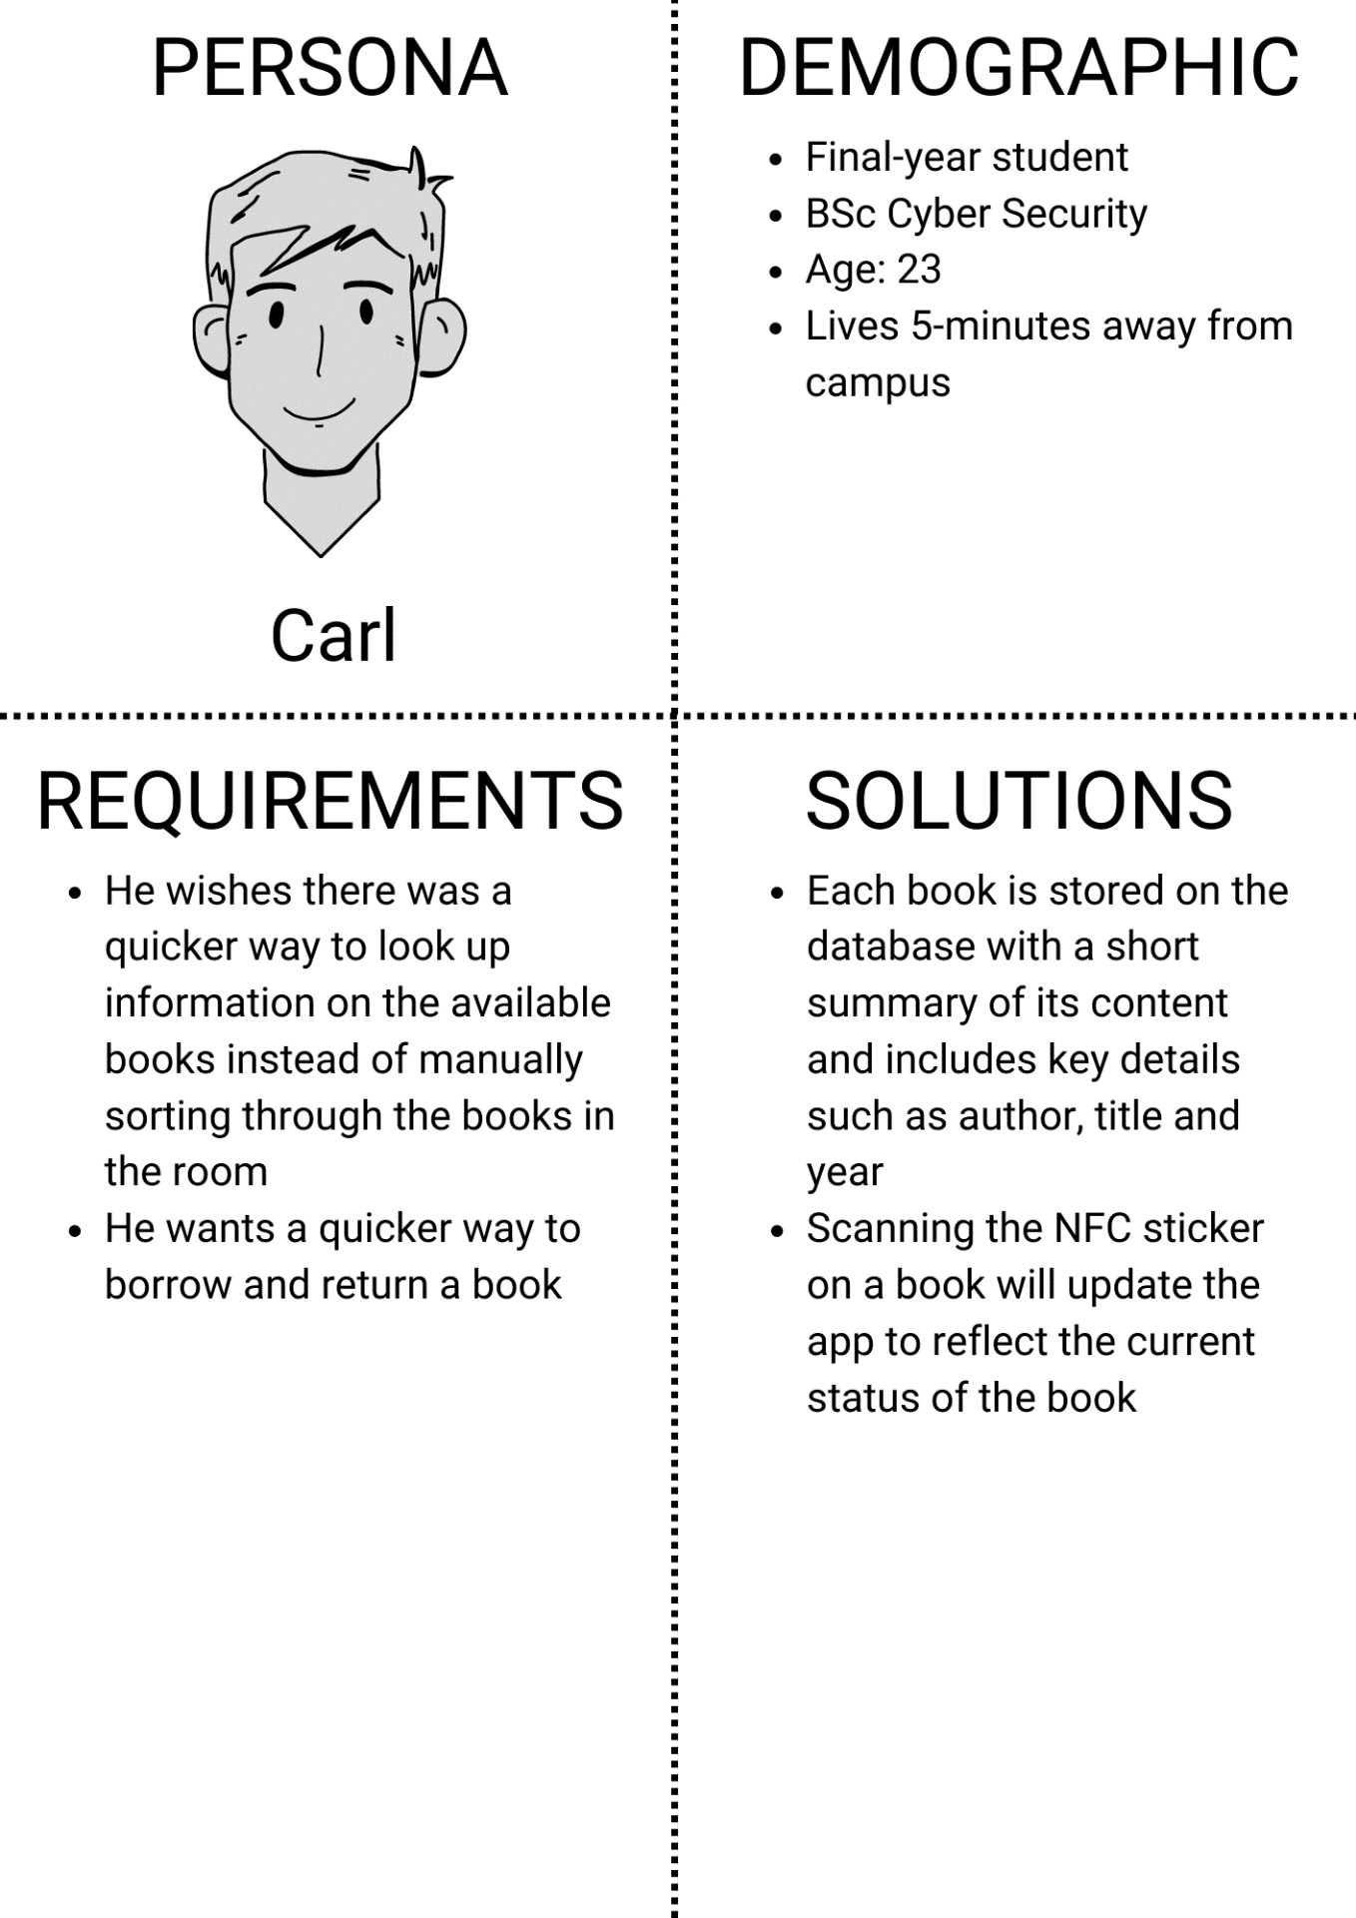

## Persona C – Beth

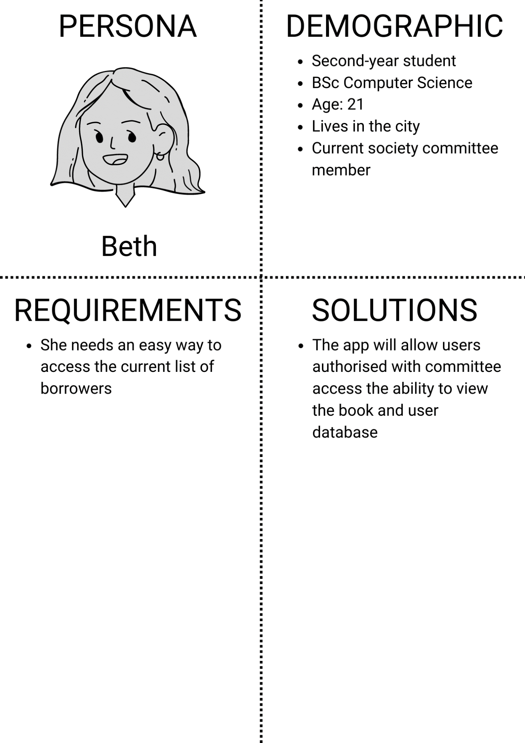

## Paper Prototype A (Before user testing)

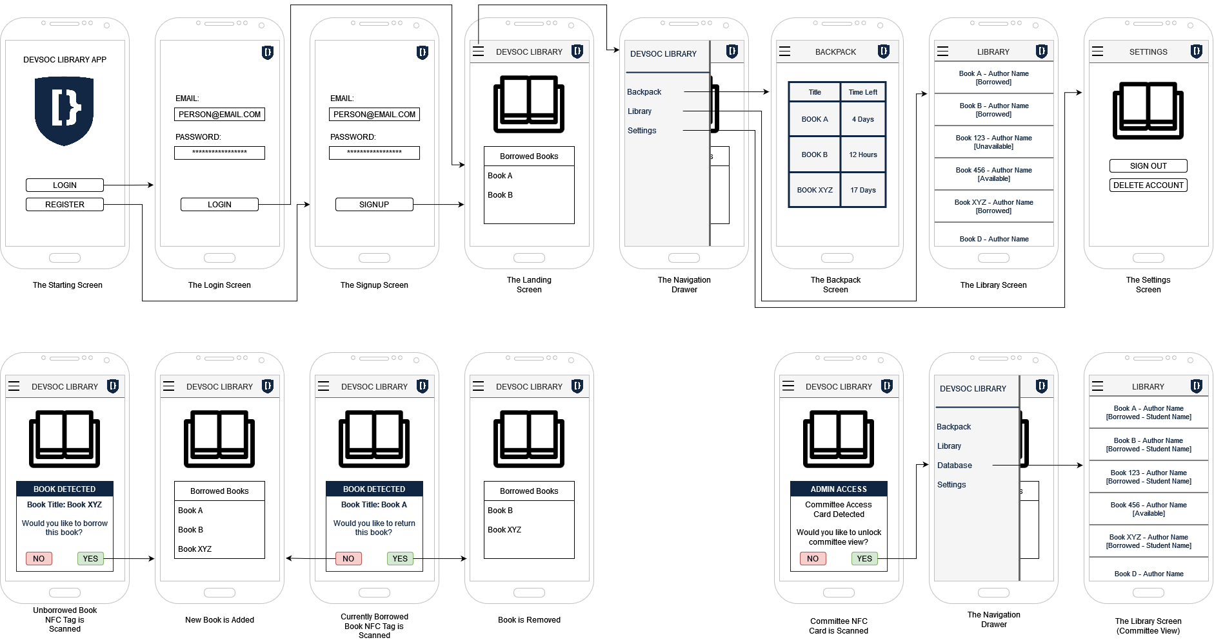

## Paper Prototype B (After user testing) – Minimum Viable Product (MVP)

# References

Bolinda Digital, 2022. *BorrowBox Library.* [Online]   
Available at: https://play.google.com/store/apps/details?id=com.bolindadigital.BorrowBoxLibrary  
[Accessed 7 November 2022].

DevSoc, 2022. *DevSoc Asset Pack.* [Online]   
Available at: https://github.com/NTUDevSoc/Asset-Pack  
[Accessed 13 November 2022].

Google Developers, 2022. *Core App Quality Checklist.* [Online]   
Available at: https://developer.android.com/docs/quality-guidelines/core-app-quality  
[Accessed 15 November 2022].

Google Developers, 2022. *Firebase Pricing.* [Online]   
Available at: https://firebase.google.com/pricing  
[Accessed 9 November 2022].

Google, 2022. *Common Buttons - Material Design 3.* [Online]   
Available at: https://m3.material.io/components/buttons/accessibility#71afc060-7055-4c40-a432-34b2de288eb8  
[Accessed 13 November 2022].

Google, 2022. *Material Design.* [Online]   
Available at: https://m3.material.io/  
[Accessed 13 November 2022].

Juretic, D., 2022. *Bookshelf - Your Virtual Library.* [Online]   
Available at: https://play.google.com/store/apps/details?id=com.bookshelf.prod  
[Accessed 10 November 2022].

Keith, J., 2022. *My Library.* [Online]   
Available at: https://play.google.com/store/apps/details?id=com.vgm.mylibrary  
[Accessed 10 November 2022].

OverDrive, 2022. *Libby.* [Online]   
Available at: https://play.google.com/store/apps/details?id=com.overdrive.mobile.android.libby  
[Accessed 9 November 2022].

WCAG, 2022. *Web Content Accessibility Guidelines.* [Online]   
Available at: https://wcag.com/  
[Accessed 8 November 2022].